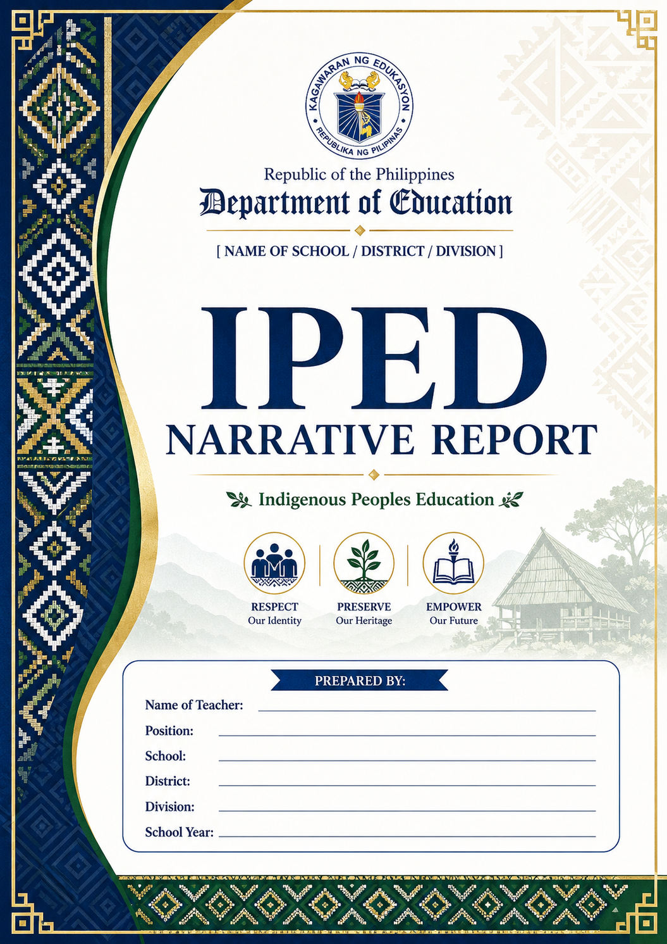

NARRATIVE REPORT
Indigenous Peoples Education (IPEd) Celebration 2025 Saniag Elementary School, Barangay Saniag, Ampatuan, Maguindanao del Sur Theme: "Ating Pandayin ang Kinabukasan, Gabay ang Katutubong Karunungan at Karapatan" "Let's Forge the Future, Guided by Indigenous Wisdom and Rights"

I. INTRODUCTION
Saniag Elementary School, in partnership with the Barangay Local Government Unit and DepEd, conducted the IPEd Celebration 2025 in observance of the International Day of the World's Indigenous Peoples and National Indigenous Peoples Month. The activity aimed to promote cultural awareness, preserve indigenous identity, and strengthen the implementation of the Indigenous Peoples Education Program in the school.
II. OBJECTIVES
1. To celebrate and showcase the rich cultural heritage of Indigenous Peoples in the community.
2. To promote respect for IP rights, traditions, and indigenous knowledge systems.
3. To encourage learners to take pride in their cultural identity and heritage.
4. To strengthen collaboration between the school, IP elders, parents, and stakeholders.
III. ACTIVITIES CONDUCTED
The celebration was held at the Saniag Elementary School Covered Court with learners, teachers, parents, and barangay officials in attendance.
Highlights:
- Cultural Dance Presentation
Learners performed traditional dances wearing vibrant indigenous attire. The costumes featured colorful patterns in red, yellow, pink, blue, and green with intricate designs of inaul and tribal prints. The performance reflected grace, unity, and pride in their cultural roots.

- Parade of Indigenous Attire / Group Photo
All learners, from Kindergarten to Grade 6, participated in a group photo wearing their traditional attire. The diversity of colors and designs showcased the unity of different IP groups in the community.

- Community Participation
Parents and community members witnessed the presentations. Some documented the event, showing support for the learners and the program.

IV. OBSERVATIONS
• Learners showed enthusiasm, confidence, and joy in performing and wearing their cultural attire.
• The event fostered a sense of pride and belonging among IP and non-IP learners.
• The decorated venue with cultural motifs and the participation of the whole school made the celebration meaningful and festive.
• The activity served as a venue for learners to experience and appreciate indigenous culture firsthand.
V. OUTCOMES
1. Increased awareness and appreciation of Indigenous culture among learners and stakeholders.
2. Strengthened implementation of IPEd in Saniag Elementary School.
3. Promoted inclusivity, respect, and unity in the school community.
4. Learners were able to express their identity and learn values embedded in indigenous traditions such as respect for elders, community, and nature.
VI. CONCLUSION
The IPEd Celebration 2025 at Saniag Elementary School was a successful and memorable event. Guided by the theme "Ating Pandayin ang Kinabukasan, Gabay ang Katutubong Karunungan at Karapatan", the school reaffirmed its commitment to culture-based education. Through dance, attire, and community involvement, learners were reminded that honoring indigenous wisdom today helps shape a better future for all.

Prepared By:
Rizel M. Alvarez
IPED School Coordinator
